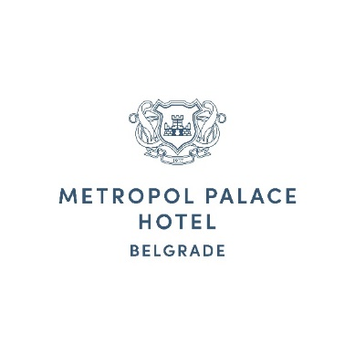Tel: +381 11 3333 144

[reservations@metropolpalace.com](mailto:reservations@metropolpalace.com)

BULEVAR KRALJA ALEKSANDRA 69 BELGRADE 11000, SERBIA

Reservation Cancellation Form

**Guest Details:**

* Full Name: _______________________________________
* Email Address: ___________________________________

**Reservation Details:**

* Arrival Date: _______________________________________
* Departure Date: _____________________________________
* Booking Confirmation Number: _________________________
* Total Amount Paid via link: __________________________

**Cancellation Confirmation:** I confirm that I am cancelling the reservation for the above room and acknowledge that I am aware that cancellation terms may apply.

**Date**: __________________________

**Signature**: _______________________________________